Part 8 — DAX

Create a dedicated blank table named _Measures to hold all measures — Home → Enter data → name it _Measures → Load, then delete its single column. Move every measure into it and hide the table.

Power BI won't let a table exist with zero columns — that's why you get that error when you try to delete the only column. A table needs at least one column to exist in the model.
The standard fix isn't to delete the column, but to hide it instead:
- Home > Enter Data > name it _Measures > give it one column (call it something like "Column1") with just one dummy row (e.g. a single blank or "1") > Load
- In Model view, right-click the _Measures table (or the column itself) and select Hide in report view
- Now create/move your measures into this table — right-click _Measures > New Measure, or select existing measures and drag/change their "Home table" property to _Measures
Since the table is hidden, that leftover column never shows up to end users — only the measures (which live at the table level, not tied to that column) are visible when you expand _Measures in the fields pane.
Alternative (cleaner, no dummy column visible at all): Use Power Query instead of Enter Data:
- Home > Transform Data > New Source > Blank Query
- Open Advanced Editor and replace the code with:
let
Source = #table({}, {})
in
Source
- Rename the query _Measures > Close & Apply
This creates a genuinely empty table (0 columns, 0 rows) with no need to hide anything, and you can assign measures to it the same way.
Either method works fine — the hide-the-column approach is more common since it's point-and-click, but the blank query trick is tidier if it bothers you having a phantom column at all.

A couple of different things are getting mixed up here — worth untangling:
"_Measures inside _Measure" — what's likely happening:
This is probably not a real nested table, but a Display Folder naming coincidence. In Power BI, "Display Folders" are a separate feature from the table itself — they're just labels you assign to measures to group them visually in the Fields pane, and they exist inside whatever table the measure's Home Table is set to. So, if you (or a template) already set a measure's Display Folder property to "_Measures" while its Home Table is also _Measures, you'll see something like:
_Measures (table)
└── _Measures (folder)
└── your measures
That's not broken — it's just redundant naming, purely cosmetic. You can leave it, or simplify it (see below).
Do you need to fix it?
No, functionally it doesn't matter. But if it bugs you visually, you can just clear the Display Folder property so measures sit directly under the _Measures table without the extra subfolder layer.
How to move your measures into _Measures:
- Go to Model view
- Click on a measure (in whichever table it currently lives under)
- In the Properties pane on the right (expand it if collapsed), find Home Table
- Change it from its current table to _Measures
- Repeat for each measure — or Ctrl + click multiple measures at once and change Home Table for all of them together
To set/clear Display Folders (optional subfoldering):
- Same Properties pane, look for Display Folder
- Type a name (e.g. "Sales" or "Time Intelligence") to create a subfolder grouping within _Measures
- Leave it blank to have the measure sit directly under _Measures with no subfolder
- You can absolutely create subfolders this way — e.g. Sales\Revenue as the Display Folder text creates a nested subfolder structure automatically
So yes, subfoldering is supported natively — just via the Display Folder property, typed with backslashes for nesting, no separate "create folder" step needed.

Part 9 — The Three Reports

9.1 Shared design standards

Yes, most of this can be made consistent across all pages — but Power BI handles it two different ways depending on what part of the standard you're talking about.

Colours & fonts → Report Theme (JSON)

This is the one true "define once, apply everywhere" mechanism. You create a theme file and every visual on every page inherits it automatically.

How to do it:

Go to View → Themes → Browse for themes (or Customize current theme)

Build a JSON theme file defining your palette and text styles, e.g.:
{
"name": "OTD Report Theme",
"dataColors": ["#0E7C7B", "#B45309", "#9B1C1C", "#475569", "#10243E"],
"background": "#FFFFFF",
"foreground": "#10243E",
"tableAccent": "#0E7C7B",
"textClasses": {
"title": { "fontFace": "Segoe UI", "fontSize": 24, "color": "#10243E" },
"label": { "fontFace": "Segoe UI", "fontSize": 10 }
},
"visualStyles": {
"*": {
"*": {
"title": [{ "fontFamily": "Segoe UI", "fontColor": { "solid": { "color": "#10243E" } } }]
}
}
}
}

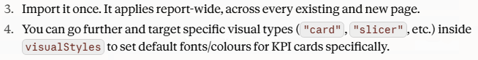

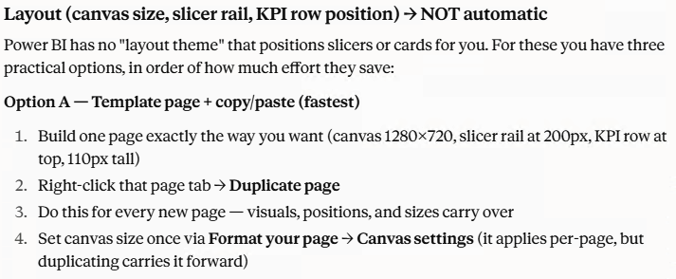

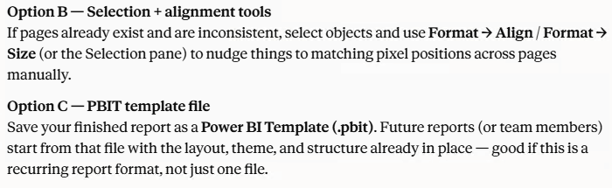

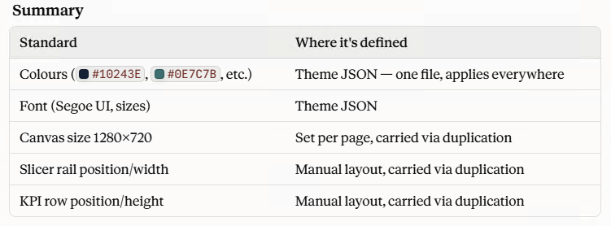

Here's an expanded theme file covering everything that can live in a Power BI theme (colours, fonts, card/table defaults). Canvas size and layout (slicer rail, KPI row) can't be set via theme JSON — I'll explain how to handle those right after.
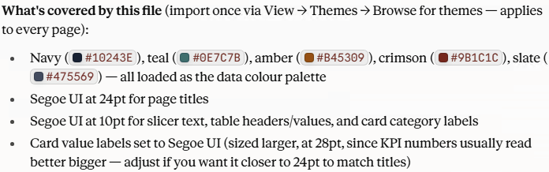

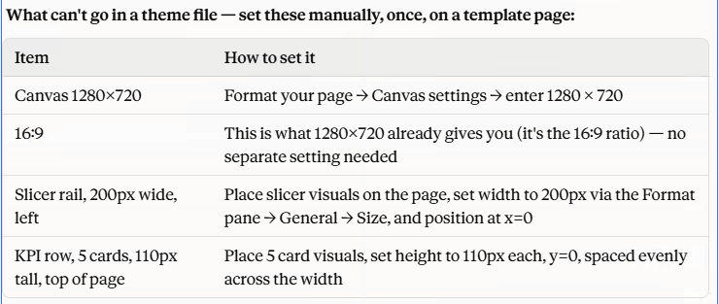

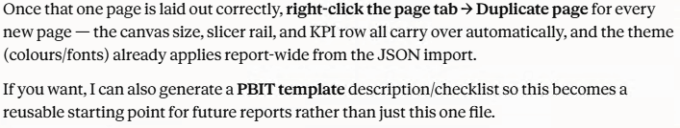

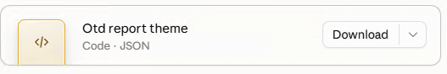

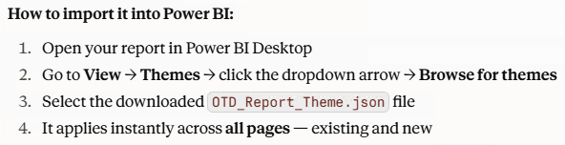

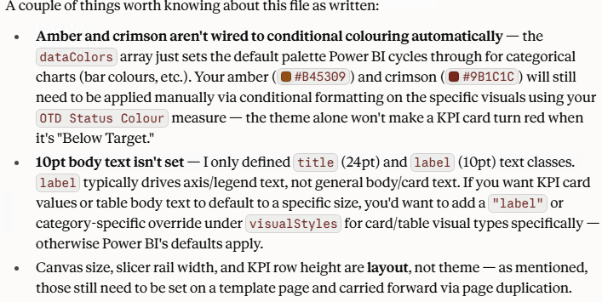

add / change font size 18 for values and 20 for column and row header in JSON file

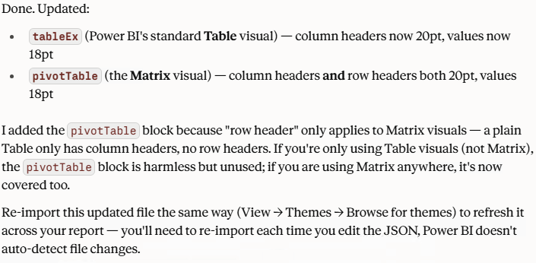

9.2 Report 1 — Network Performance
This report answers the COO’s question. It must lead the reader from the symptom to the correct diagnosis, not merely display the symptom.

KPI row
Card | Measure | Formatting
On Time % | [On Time %] | Percentage, 1 dp, conditional colour via OTD Status Colour

Card 1

On Time %

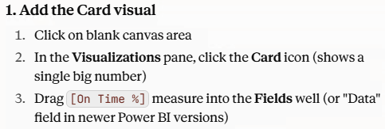

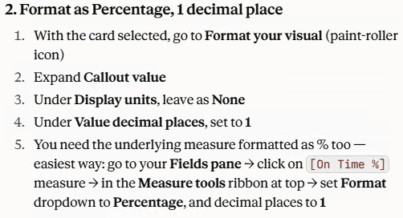

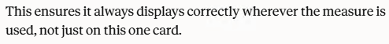

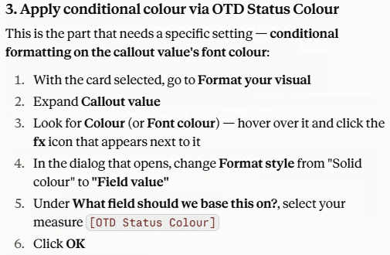

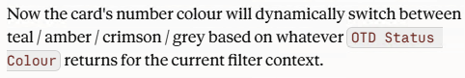

Card | Measure | Formatting
vs Target | [OTD vs Target pp] | Number, 1 dp, "pp" suffix, red if negative

Card 2

vs Target

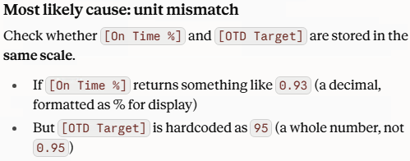

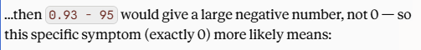

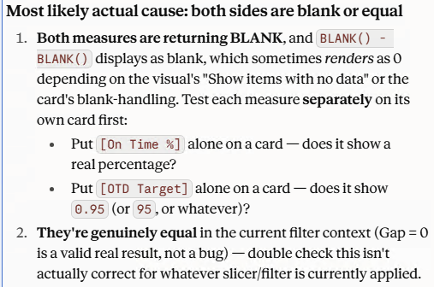

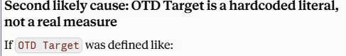

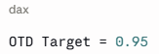

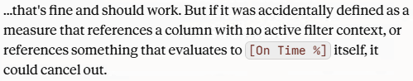

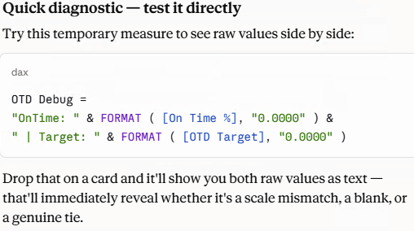

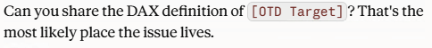

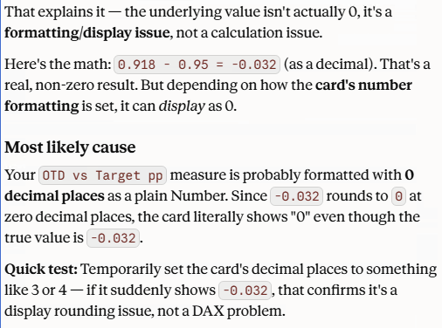

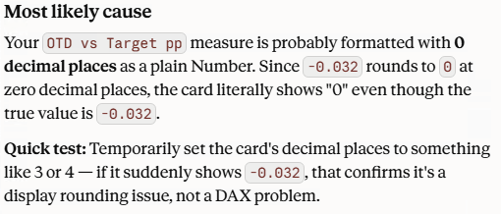

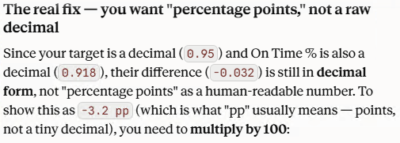

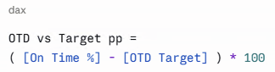

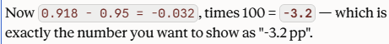

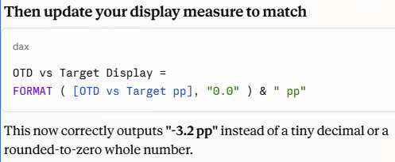

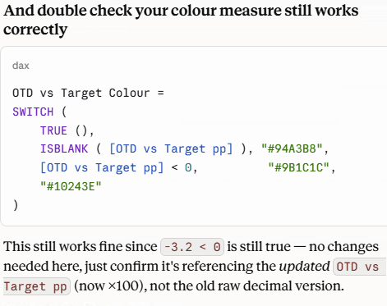

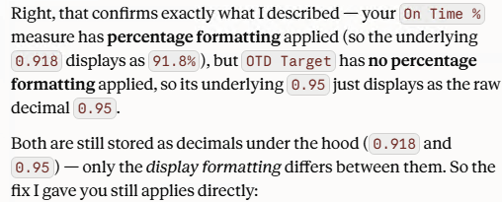

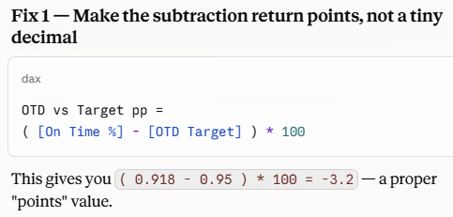

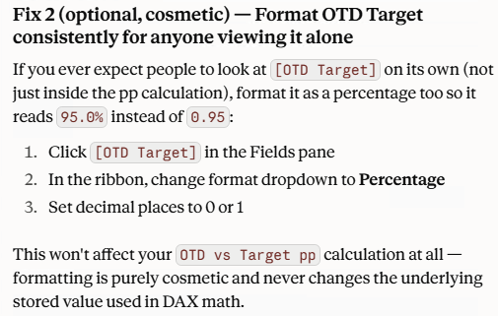

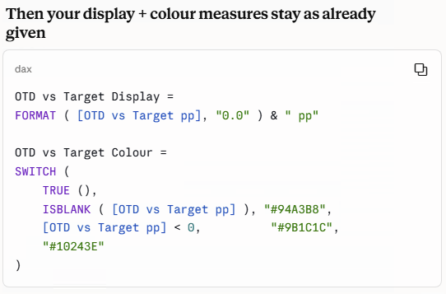

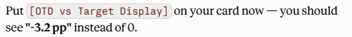

Card 3

YoY Change

Card | Measure | Formatting
YoY Change | [On Time % YoY pp] | Number with [OTD Trend Indictor] prefix

On Time % YoY pp = [On Time %] - [On Time % LY]

Format 0.0 pp

On Time % = AVERAGE ( 'meridian_freight v_consignment_delivery'[is_on_time] )
Format is %

On Time % LY =
CALCULATE ( [On Time %], SAMEPERIODLASTYEAR ( DateTable[Date] ) )
Format is %

OTD Trend Indicator =
VAR Change = [On Time % YoY pp]
RETURN
SWITCH (
TRUE (),
ISBLANK ( Change ), "",
Change > 0.005, UNICHAR ( 9650 ), -- filled up triangle
Change < -0.005, UNICHAR ( 9660 ), -- filled down triangle
UNICHAR ( 9644 ) -- flat bar
)

Format is Text

